**Lesson 8 Demo 1**

**Docker Community Edition Installation**



Steps to be followed:

1. Install Docker CE from Docker Repository
2. Verify the correctly installed Docker Engine

**Step 1: Install the Docker CE from Docker Repository**

1.1 Use the following command to update the apt package:

***sudo apt-get update***

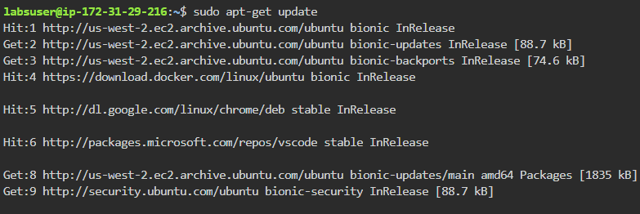

1.2 Use the following command to install packages to allow the apt to use a repository over HTTPS

***sudo apt-get install \***

***apt-transport-https \***

***ca-certificates \***

***curl \***

***gnupg \***

***lsb-release***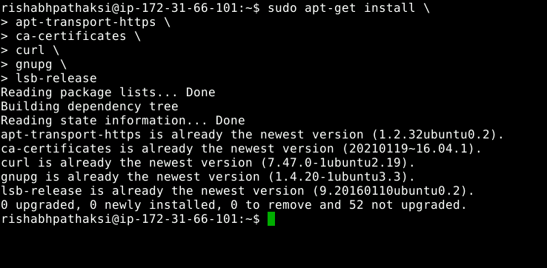



* 1. Use the following curl command to add Docker’s official GPG key:

***curl -fsSL https://download.docker.com/linux/ubuntu/gpg | sudo gpg --dearmor -o /usr/share/keyrings/docker-archive-keyring.gpg***



1.4 Use the following command to set up a stable repository:

***echo \***

***"deb [arch=amd64 signed-by=/usr/share/keyrings/docker-archive-keyring.gpg]*** [***https://download.docker.com/linux/ubuntu \***](https://download.docker.com/linux/ubuntu%20%5C)

***$(lsb_release -cs) stable" | sudo tee /etc/apt/sources.list.d/docker.list > /dev/null***

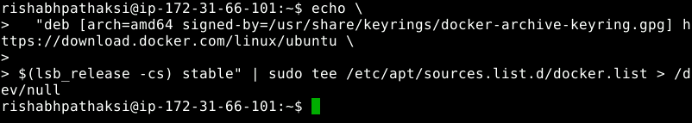

1.5 Use the following commands to install the latest version of Docker CE and check the version:

***sudo apt-get install docker-ce***

***docker --version***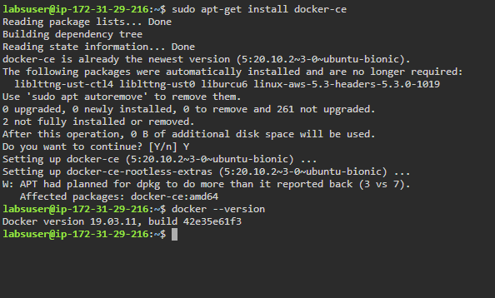

**Step 2: Verify the correctly installed Docker engine**

2.1 Use the following command to verify the Docker engine:

***sudo docker run hello-world***